Using the Projection Screen at HCG

Laptop Resolution: 1680 x 1050
Projector Respolution: Signal -> Aspect -> Auto Setup Off
-> Full
Projector Zoom: As tight as possible (A)
Projector Keystone L/R: Centered (the slider should clikc into place at center) – NOTE most of the time you don't need to adjust this keystone, just physically rotate the projector
Projector Position: Align center, right side, and rear of projector with the red tape on the window (1), right (2) and seating (3) sides of the control room desk, respectively
(1)

(A)

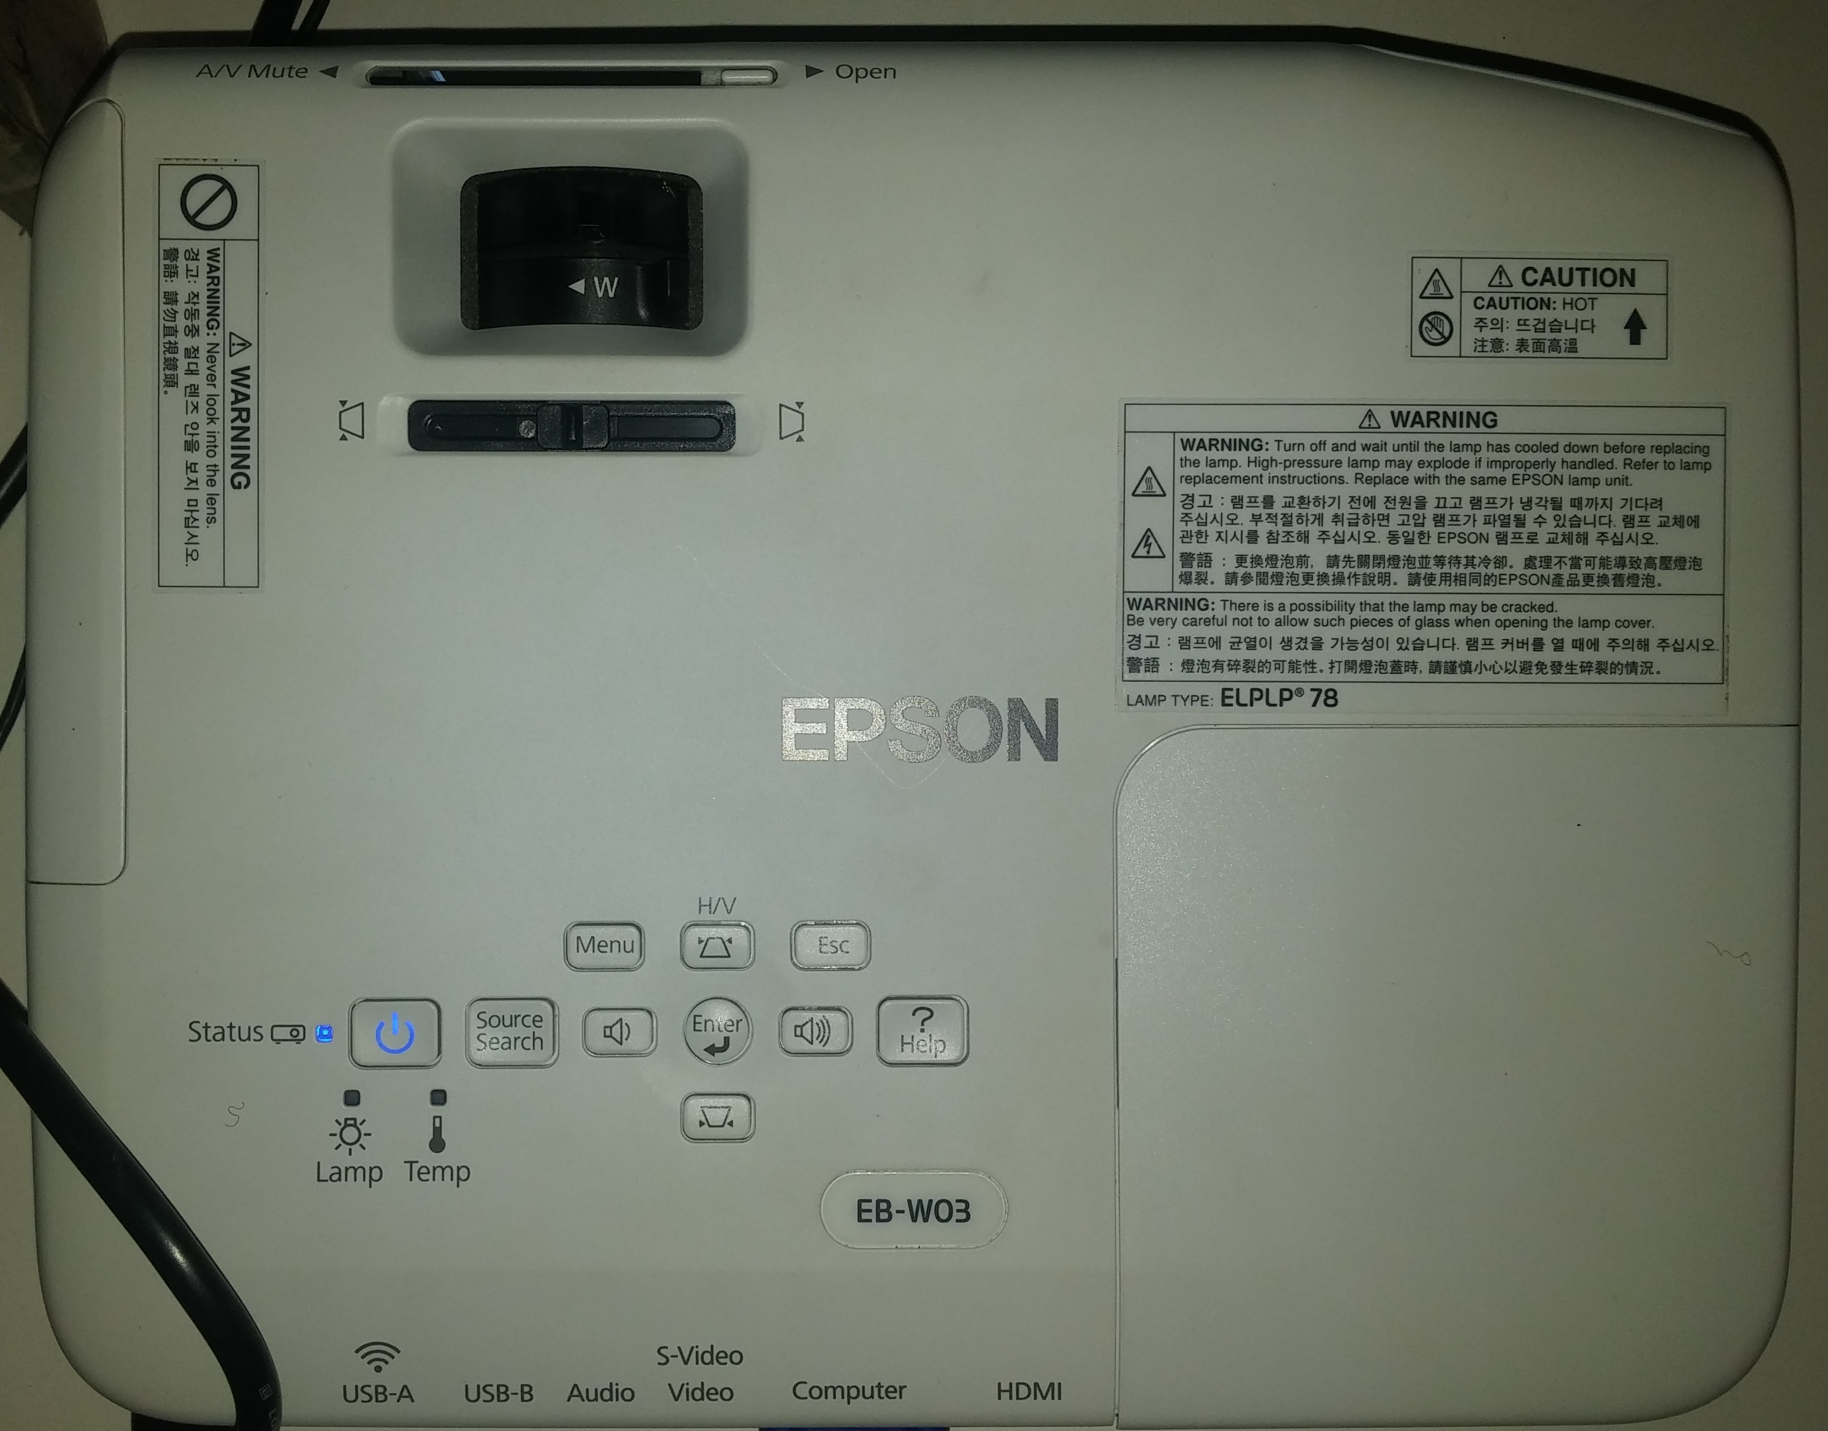

(B)

(2)

(3)

Screen Stand: Align the red tape on the feet of the stand to the second crack in the tiles from the control window
Projected Image: Full desktop should line up with the tapemarks on the back of the screen BUT BE SURE TO CHECK THAT SUBJECT CAN SEE ALL FOUR CORNERS OF THE SCREEN ANYWAY!

Current Screen::DOV Measurements:
32 Ch Area of mirror: 16x6 cm2 (wxh)
Area of screen in mirror (meL): 5.2x3.2 cm2
Viewing distance, eye-mirror: ~16cm

24cm stimuli appear ~8.5 dov as measured by meL's thumb
~1.8cm in mirror

Viewing distance eye-screen: ~330cm

ppd = pi * (screenRect(3) - screenRect(1))/ atan(monWidth/viewDist/2) / 360 = 91.0087ppd

